PAPER 1: PLANT DISEASE DETECTION BY IMAGING SENSORS

PUBLICATION: INRES

DATE: Jan 2016

Abstract:

Precision agriculture is a crop management system based on the spatial and temporal variability in crop and soil factors within a field. This system aims to attain real-time, robust mapping systems for crop, soil, and environment variables to facilitate a management decision.

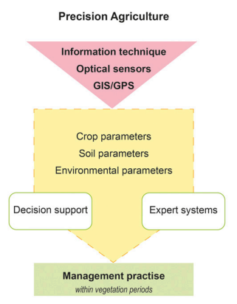

Conclusion:

Only a highly interdisciplinary approach with a close link to practical agriculture can lead to powerful solutions for diagnosis and disease detection with a high accuracy and sensitivity that will improve plant health management.

PAPER 2: Plant Leaf Disease Prediction

PUBLICATION: Research Gate

DATE: July 2021

Abstract:

The Indian economy relies heavily on agriculture productivity. A lot is at stake when a plant is struck with a disease that causes a significant loss in production, economic losses, and a reduction in the quality and quantity of agricultural products. It is crucial to identify plant diseases in order to prevent the loss of agricultural yield and quantity.

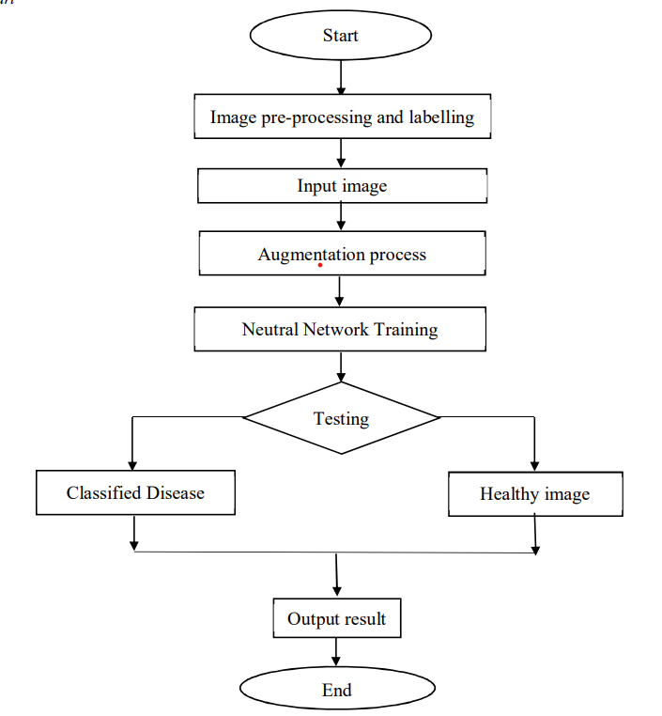

Conclusion:

Even though there are various methods for detecting and classifying plant diseases using automatic or computer vision, research into this field has been lacking. In addition, there are few commercial options, with the exception of those focusing on the identification of plant species via photographs. Over the last few years, there has been tremendous progress in the performance of convolutional neural networks. The new generation of convolutional neural networks (CNNs) has shown promising results in the field of image recognition. A novel approach to automatically classifying and detecting plant diseases from leaf images was examined through this project utilizing deep learning techniques. With an accuracy of 90%, the developed model could distinguish healthy leaves from eight diseases that could be observed visually. On the basis of this high level of performance, it becomes apparent that convolutional neural networks are highly suitable for automatic diagnosis and detection of plants.

PAPER 3: IMAGE BASED SYSTEM USING DEEP LEARNING

PUBLICATION: RESEARCH GATE

DATE: August 2022

Abstract:

Plant diseases mostly harm the leaves, resulting in a loss in agricultural output's quality and quantity. Plant disease is the most common cause of large-scale crop mortality. India is a country where people's livelihoods are heavily reliant on agriculture. The disease has caused chaos in the agricultural industry. The human eye's perception is not quite as sharp as it needs to be to notice minute variations in the sick leaf region. It needs a complex process that requires both plant expertise and a large amount of processing time. As a result, plant diseases can be detected using machine learning.

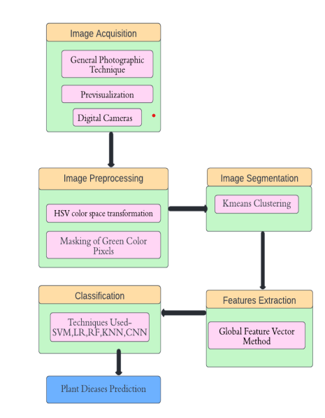

Conclusion:

In this research article, an approach for plant disease prediction and classification has been proposed using deep learning and machine learning classifiers. Classification is performed after the segmentation and feature extraction process. Diseases have been broadly classified into three categories namely Fungal, Bacterial and viral. A dataset consisting of 5,3200 images has been trained upon SVM, KNN, Logistic Regression, Random Forest, and CNN. Among all the classifiers, CNN gives the best prediction accuracy of 97.34%. In the future, image augmentation can also be applied to the dataset to increase its size and compare the results between all classifiers as well as The agricultural department seeks to automate the process of recognizing high-yield crops (real-time). This method can be automated by displaying the prediction result in a web or desktop application. To make the work easier to implement in an Artificial Intelligence context

# PAPER 4: Disease Prediction using ML

PUBLICATION: RESEARCH GATE

DATE: November 2021

Abstract:

Machine learning is computer programming to optimize performance using sample data or past data. Machine learning is the study of computer systems that learn from data and experience. The machine-learning algorithm has two parts: training, testing. Predict disease using symptoms and patient history Machine learning technology has been striving for decades. Machine learning technology provides an immeasurable platform in the medical field for health issues to be effectively resolved. We apply machine learning to keep complete hospital data. leading to the reference in the current text must match the list of references at the end of the document.

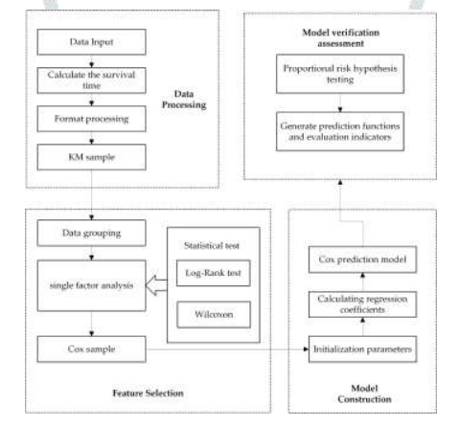

Conclusion:

Comparing the accuracy between random forest, naïve bayes and decision tree algorithm. We conclude that random forest has the highest accuracy as compared to the other 2 algorithms. But for our project all 3 models are combined to give the best accuracy output

PAPER 5: Forecasting Plant and Crop Disease

PUBLICATION: MDPI

DATE: Jan 2021

Abstract:

Crop and plant diseases entail serious implications for food security and production losses. Over the years, the lasting global trade and the changing climate have not only exacerbated the existing favorable conditions for plant and crop disease but have also created new conditions with which agriculture must now contend.

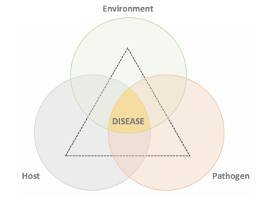

Conclusion:

The prediction of plant and crop disease is a complex problem to be solved due to the interaction of several environmental and climatic factors. Over the last 10 years, the literature has presented considerable advancements in understanding these dynamic processes by adopting different scientific approaches. As we observed, the problem under study requires high-quality, labeled data. However, the lack of open data is slowing the advance of knowledge in this agricultural sub-domain. Indeed, regarding the state of the art, only a limited number of contributions has been presented in the literature from 2010 to today. The majority of these have focused on few pathogens and crops; furthermore, only a few of these have considered data from various heterogeneous sources to predict disease occurrence. These gaps are hindering progress in achieving development goals and creating products that are able to face realworld scenarios, and so more effort is required in data collection and in developing novel solutions to prevent and mitigate the impact of crop and plant disease to food production, especially for those crops which represent staple foods for millions of people who live in the least developed countries.